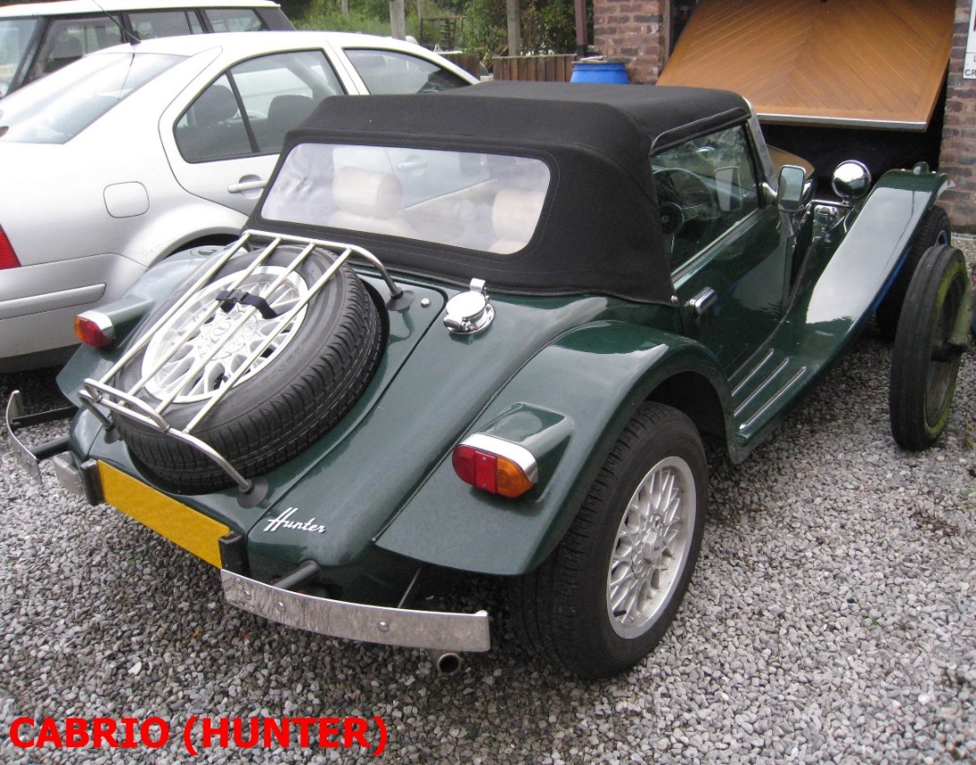
Picture DC

Paul Moorhouse had been working on the design of a submarine (and building it at Marlin Engineering) from about 1984/5, alongside the Roadster/Berlinetta production, and in order for him to be able to spend more time and effort on this, the rights to the Roadster (and it’s 2+2 bigger sister the Berlinetta) were sold to Yorkshire Kit Cars (YKC) in 1992.

[See www.steelfish.com for Paul’s submarine building story]

Steve Himsworth had started YKC Engineering Ltd in 1985, following his 1983 purchase of an unfinished Triumph based Roadster, which signalled the start of the collaboration between Marlin and YKC.

In time YKC became the Northern Build Agent for Marlin, and when Don Burt joined Steve in 1993 as a partner in YKC they bought the rights for the Roadster and Berlinetta from Marlin, and production of the kits was moved to Yorkshire, with some of the last Marlin built Marina kits being sold under the YKC name. YKC then produced Roadster kits themselves to the Marlin design but using their own kit number sequence. Initially the cars were Marina/Ital 1.3/1.7/1.8L engined, but as time went on several different engines (including Fiat, Ford, Mitsubishi, and Maestro) started to be utilised in both LWB and SWB variants.

A ”new” Roadster was designed by Steve Himsworth and Clive Gamble, reworking the model with technology from the Ford Sierra, and the cars/kits were produced by YKC

(note : in the background of the following YKC Roadster picture is the prototype V8 powered YKC “Raider”)

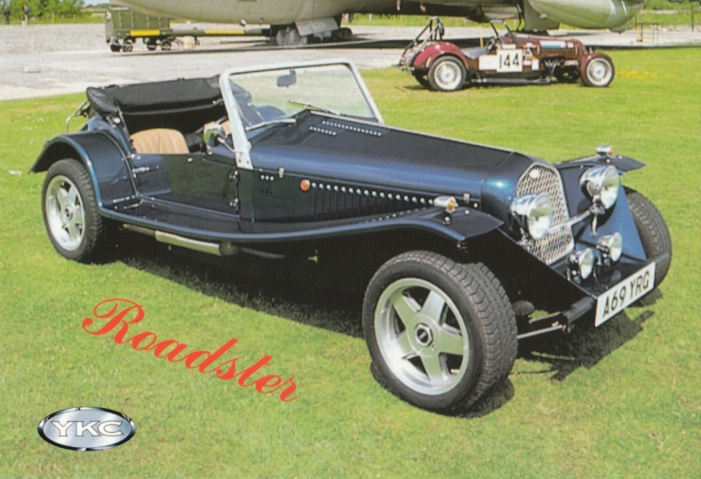

The Sierra based Roadster was further redesigned to become the Imola, the Romero, the Julietta and the Mille Miglia.

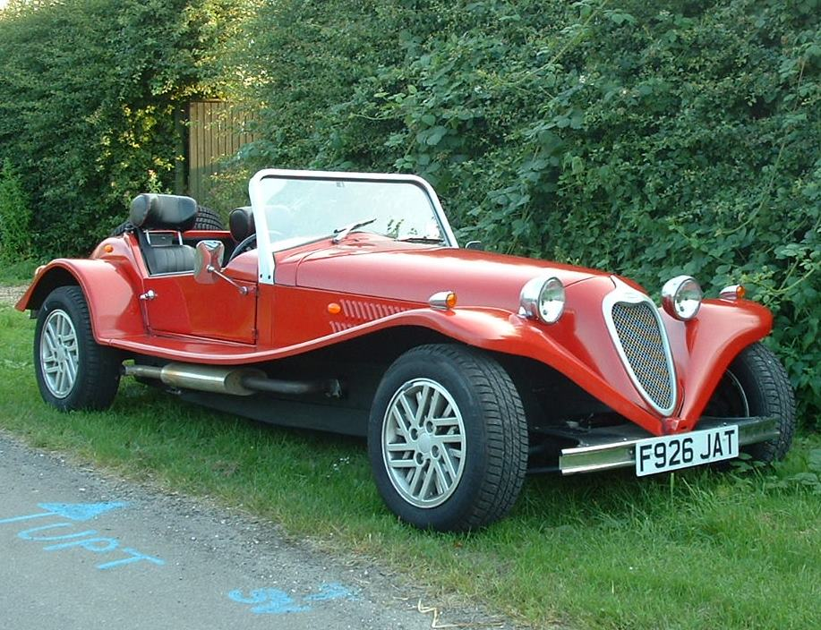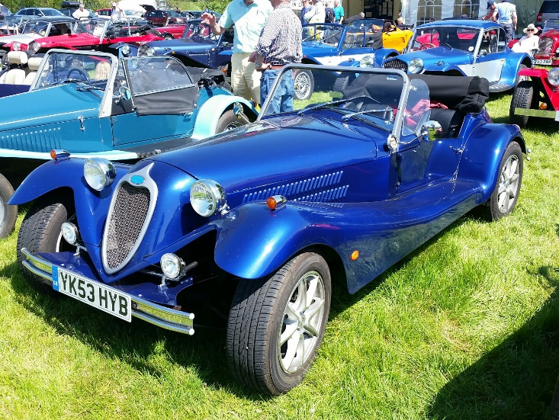
Imola/Romero Julietta

The Mille Miglia was visually similar to the Julietta, apart from the aeroscreens. The removal of the strength of the windscreen surround required changes to the body structure.
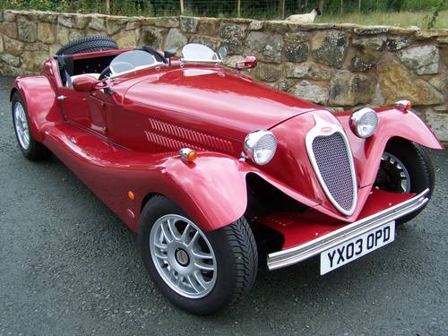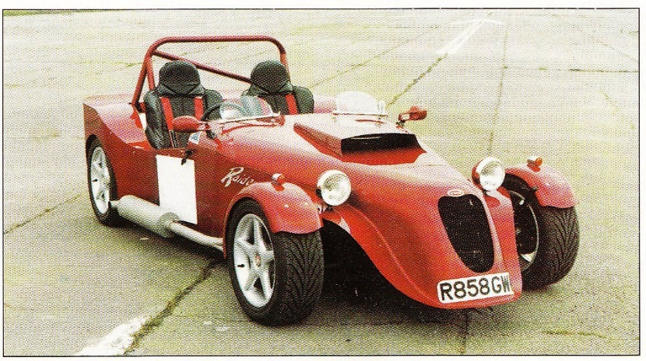
Mille Miglia Raider
Two “Raiders” were built, and the second is pictured above with a competition body when owned by ASC.

YKC as a company was sold on to become Aquila Sports Cars (ASC) and had further changes of name/ownership over time, before succumbing to the downturn in the kit car market

+ + + + + + +

Returning to the main story, in 1994/5 the Marlin company was bought by Terry and Mark Matthews and they, as the new owners of the Cabrio model, introduced the “turnkey” Hunter alongside the Cabrio kits. Using the Cabrio as its base, the Hunter was a factory-built car featuring a high quality of assembly to customers own ideas and specifications, which made their chosen car unique.

A little later, in response to a perceived demand for the Lotus 7 type of car, Mark led the design of the Sportster, based around Ford components. The car had more room inside than a “7” type, weather equipment, doors and boot space, and Sportster kits went into production in 1997.

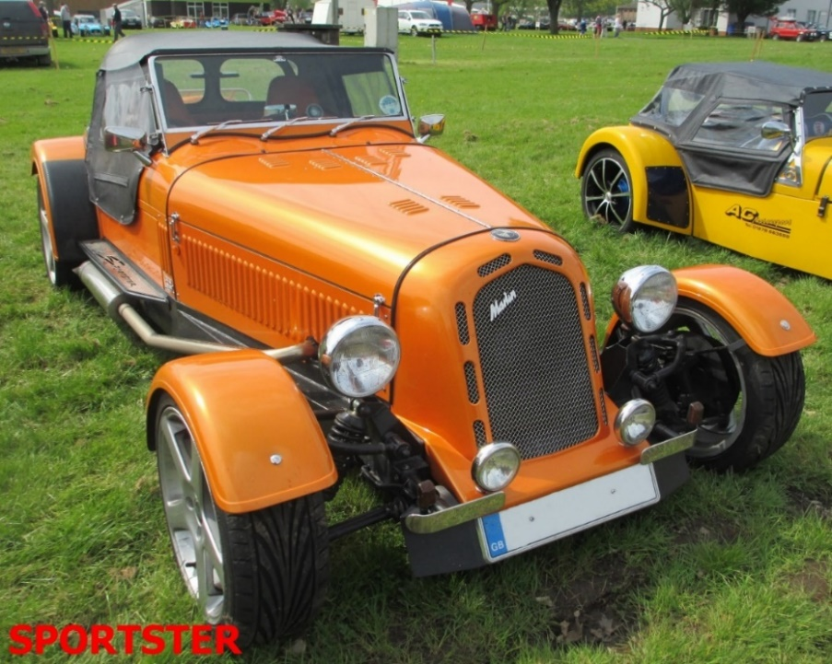

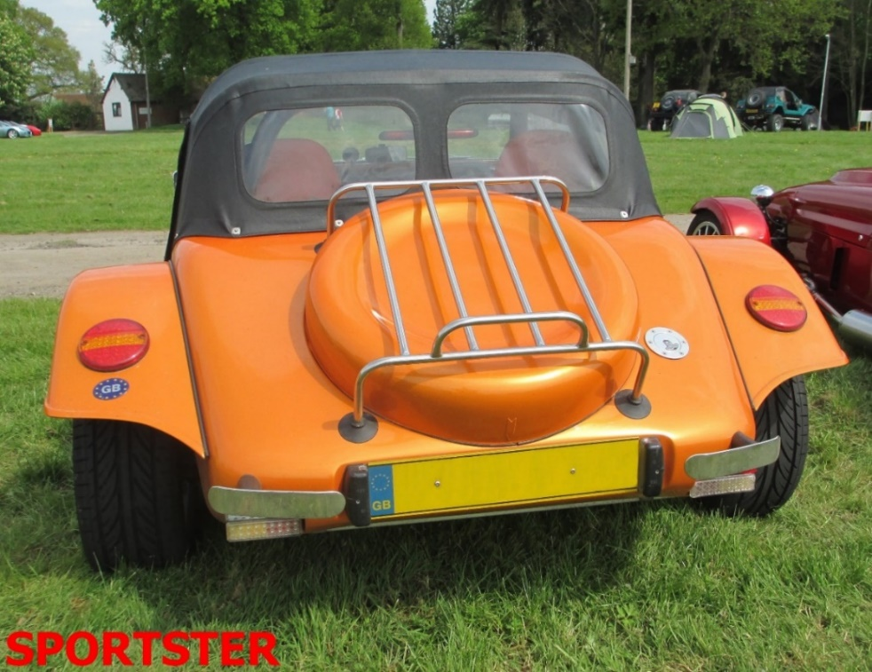
Pictures DC

In 2002 the Sportster was re-launched with a brand-new suspension and engine package, the older Ford components being replaced by parts sourced from BMW's 3-series. With this upmarket, yet affordable new donor came the promise of more exciting engine options (over 320bhp with the M3 Evo unit) and more refined and capable suspension and braking components. Once again using this new BMW package allowed the builder to assemble a Sportster using just one donor.
Also in 2002, and to celebrate twenty years of the Marlin name, the factory embarked on its most audacious project yet. The V8 powered Makaira was a benchmark car for Marlin, embodying everything the company had learnt in developing the turnkey Hunter, to produce a highly exclusive, all aluminium bodied traditional roadster. Production difficulties meant that the wings were made in standard Marlin fashion ie f/glass.With a price tag of over £40,000, this beautiful car took Marlin into yet more unchartered waters and continued the company's heritage of pushing the boundaries – but unfortunately only one was ever built.
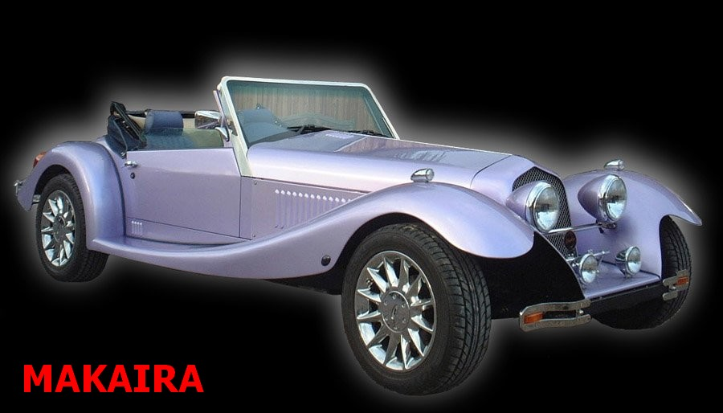
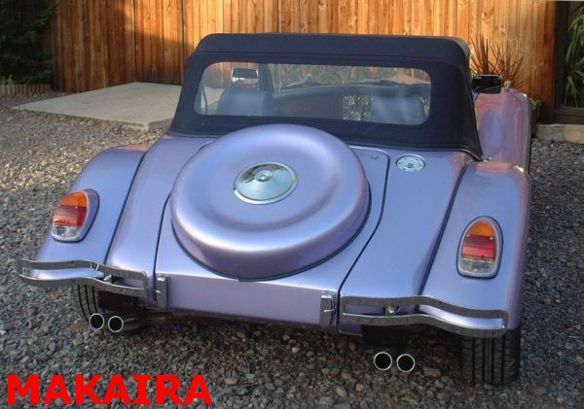
Pictures Copyright Marlin

The original launch of the Sportster had seen Marlin coming into more regular contact with a younger customer, and the Kool Kars 5exi was launched in 2003. Designed around the Rover K-Series engine/gearbox unit, with the fibreglass body panels on a space frame chassis this car offers a low-cost, easy-build with contemporary styling. Despite the move to a mid-engine layout the 5exi maintains many of the traditions of Marlin engineering, once again using an unusually large number of components from a single source.
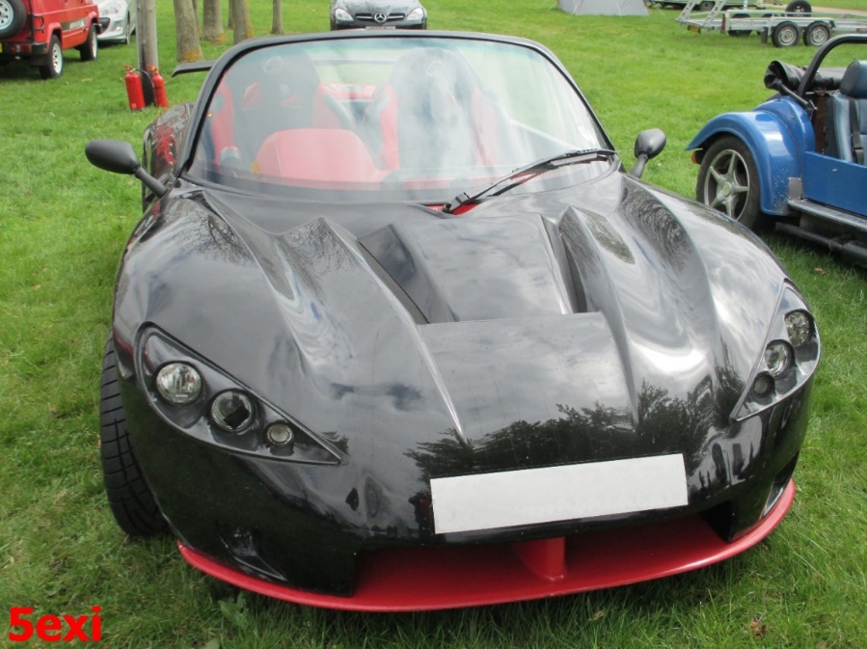
Over time, the car has been changed with the addition of full height doors and the option of using Honda's Type R VTEC engine.
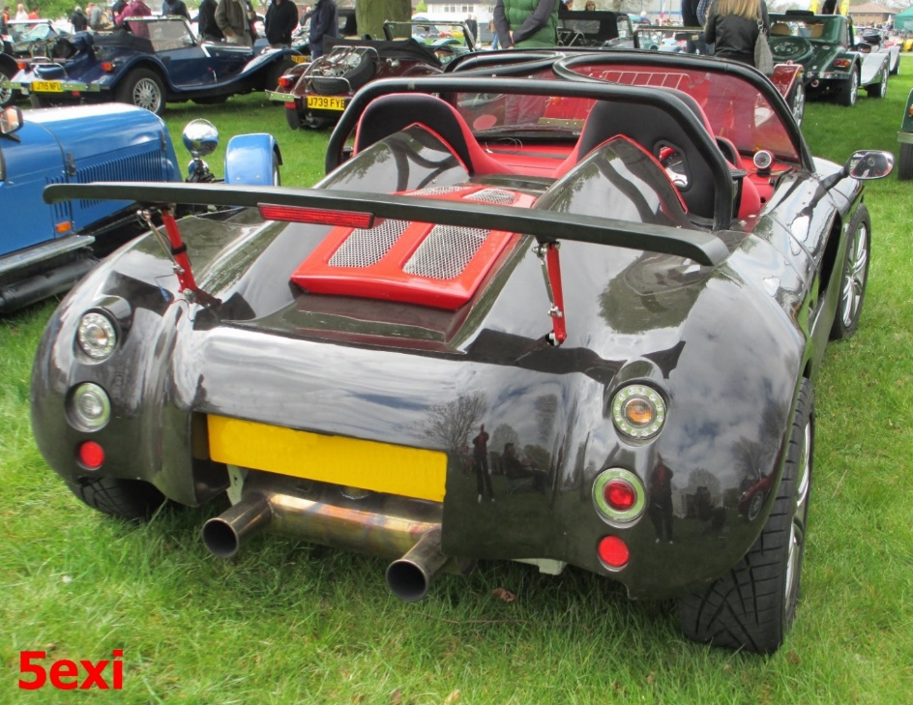
Pictures DC

The story is now almost up to date, so I shall end it here with the comment that the business was put up for sale in 2019.
Total Marlin kit production is not known exactly, but best estimates we have for the earlier cars are: Roadster (all variants) about 2500 -- Berlinetta about 440 -- Cabrio / Hunter about 180 and

The best guess scenario for YKC and Aquila together seems to be Romero 80 -- Imola 20 Julietta 40 -- M Miglia 10

DC March 2023 == == == ==

